PRESS RELEASE | 02/18/2021
 | Forchtenberg

müller coax now a World Market Leader Champion
Renowned institutions distinguish the company

müller co-ax ag is the newest member of the World Market Leader Index. In this Champions League of the German economy, the company impresses with innovative solutions in the field of coaxial valve technology and high-pressure fittings. The World Market Leader Index relies on an objective and transparent selection process.
The financial magazine Wirtschaftswoche, the University of St. Gallen with Professor Christoph Müller, and the Academy of World Market Leaders (ADWM) with its founder and managing partner, former Minister
of the Economy Dr. Walter Döring, compile the World Market Leader Index (Weltmarktführer-Index),
in which German world market leaders are chosen according to strict,
scientifically verified, and transparent criteria.

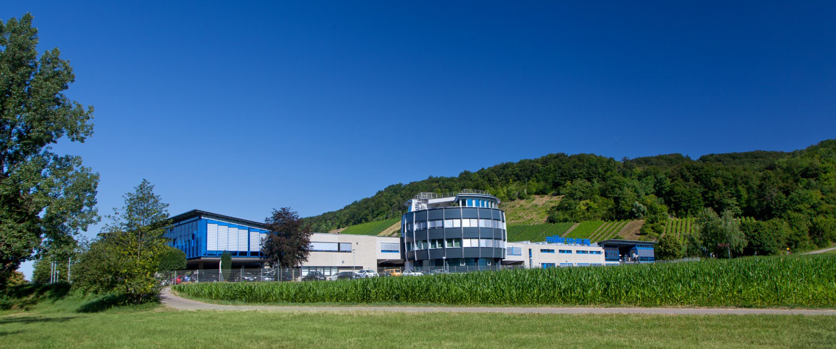
Caption: müller co-ax ag, based in Forchtenberg, Germany, has been setting standards in the development of coaxial valves for decades.

müller coax, an owner-managed company and leading global manufacturer for coaxial valve technology and high-pressure fittings which constantly sets new standards in the industry, impressed the judges and obtained the title "World Market Leader Champion". Valves for a wide range of media and applications are developed and manufactured at the company's facilities in Forchtenberg. Particularly impressive are the company's products for specific and challenging applications in the mechanical engineering, marine, chemical, energy, oil and gas, aerospace and construction markets.
müller coax greatly values product quality and innovations for the future of valve technology. With subsidiaries in England, Italy, Spain, Singapore and the USA, alongside numerous distributors worldwide, the company has a global sales and service organization.
"We are very proud of this award, as it once again underlines our outstanding expertise. Our customers can place their trust in us and our valve technology. We always have our finger on the pulse and deliver solutions for current and future market developments," explains Friedrich Müller, CEO at müller co-ax ag.
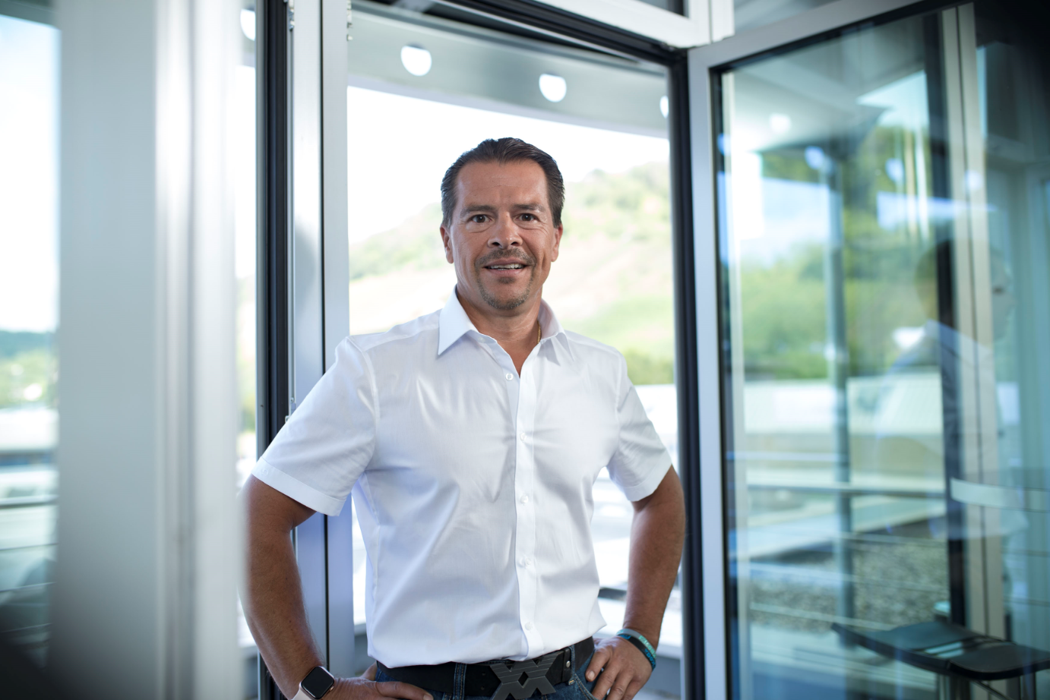
Caption: Friedrich Müller is CEO at müller co-ax ag and owner of the müller coax group

Press contact

müller co-ax ag

Katja Krämer
Marketing & Communications
Phone: +49 (0)7947/ 828-614
katja.kraemer@co-ax.com

