PRESS RELEASE | 17.11.2021
 | Forchtenberg, Germany

Efficient oxygen production using coax® valve technology

The demand for oxygen has been increasing even before the COVID-19 pandemic requirements. As well as the medical technology field, other industries require oxygen for their operations such as waste water treatment, gas, welding by blowtorches, mining, furnaces, and aquaculture such as shrimp farms.
The müller coax customer PCI, based in the USA, develops and produces mobile systems for producing oxygen on-site. To produce oxygen from air, PCI uses Vacuum Swing Adsorption (VSA) technology whereby oxygen is separated from the inflowing air. The company’s systems successfully use coax® valves which prove their worth thanks to their many benefits.
Compared to the commonly used Pressure Swing Adsorption (PSA) technology, the VSA technology works below atmospheric pressure, representing an efficient alternative in terms of complexity level, performance, and cost. The air is filtered through a molecular sieve in an adsorption vessel”. The desired product, in this case oxygen, is partially diverted into a flushing tank. To prevent impurities and to make the process more efficient, oxygen is flushed back in after each adsorption process.
PCI’s technology eliminates the need for compressed air. To ensure that the flushing tank is safely sealed, the company relies on coax’s dependable, efficient valve technology. The directly controlled coaxial valves fulfil their function as flush valves. “Especially with flush valves, it is important that the valves guarantee a 100% seal,” says Ralf Hinz, managing director of our subsidiary co-ax valves inc. in the USA. The subsidiary takes care of the customer in its home country.
The unique coaxial valve technology enables a reliable process flow, thanks to its quick and reproducible switching times. The valves also master the application’s frequent switching operations in a similar trouble-free manner. “Thanks to their coaxial design and compact construction, the valves fit perfectly in the pipes, enabling high throughput even with high diameters. Furthermore, the coaxial valve technology enables air to flow through from both sides, thereby combining two functions in one valve. This represents enormous cost savings for our customers, as there is no longer a need for additional components,” says Hinz.
coax’s own production processes have been designed for applications that require the very highest purity. For example, clean room assembly is offered for oxygen applications.

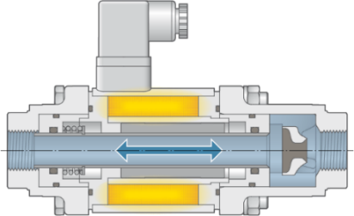
Caption: Air can flow through at both sides, representing a space-saving solution.
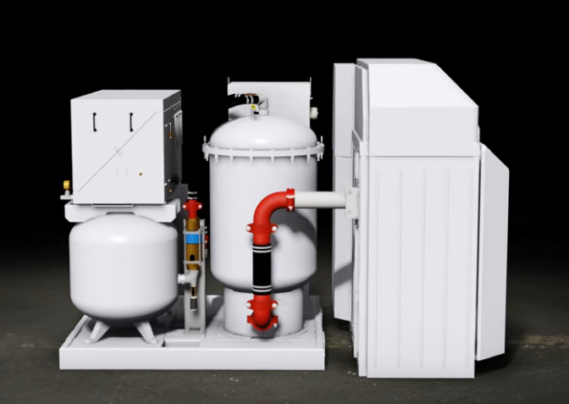
Caption: coax® valves used in PCI’s oxygen systems

Press contact
müller co-ax gmbh
Katja Krämer
Marketing & Communication
Telephone: +49 (0)7947/ 828-614
katja.kraemer@co-ax.com

